**10 Contrasting the effects of rubella vaccination between high and low transmission settings**

In this practical, you will be applying the crude forces of infection calculated in the last practical to contrast the transmission dynamics of rubella between China and the UK and to assess how different vaccination strategies will affect the overall serological profile in the population and the average age at infection.

<Summary of the key parameters describing the transmission dynamics of rubella for China and the UK>

|  |  |  |  |  |
| --- | --- | --- | --- | --- |
| Population | FOI | Average age at infection | R0 | Herd immunity threshold |
| UK | 11.59 | 8.6 | 6.95 | 86% |
| China | 20.32 | 4.9 | 12.19 | 42% |

Set up an age-structured SEIR difference equation: Individuals are stratified into annual age strata between the ages 0 and 59 years and are assumed to exit the model at the end of their 59th year of life. The population has a rectangular age distribution with 1000 individuals in each age group. For simplicity, we will assume that individuals mix randomly in the population.



Pre-infectious period 10 days

Infectious period 11 days

Initial values of each individuals of age group (S,E,I,R)=(999,0,1,0)

Run the model for 300 years by setting of R0=12.19 to describe the transmission dynamics of rubella for China:

1. What is the long-term average daily force of infection ($β*I$) in the model? Is it consistent with the overall (annual) force of infection for China?

The long-term average daily force of infection is 0.000557 per day and the average annual force of infection is 0.2032 per year, which is consistent with the value estimated using the seroprevalence.

To simulate the impact of different levels of vaccination coverage on the transmission dynamics of rubella, vaccination of newborns is introduced 100 years after the beginning of simulation with 40% vaccination coverage:

1. How does the introduction of infant MMR vaccination affect the long-term average force of infection? According to the formula A=1/λ, what is the long-term average age at infection following the introduction of infant MMR vaccination?

The introduction of infant MMR vaccination decreased the average daily force infection to 0.000334 per day and the average age at infection is 8.21 years.

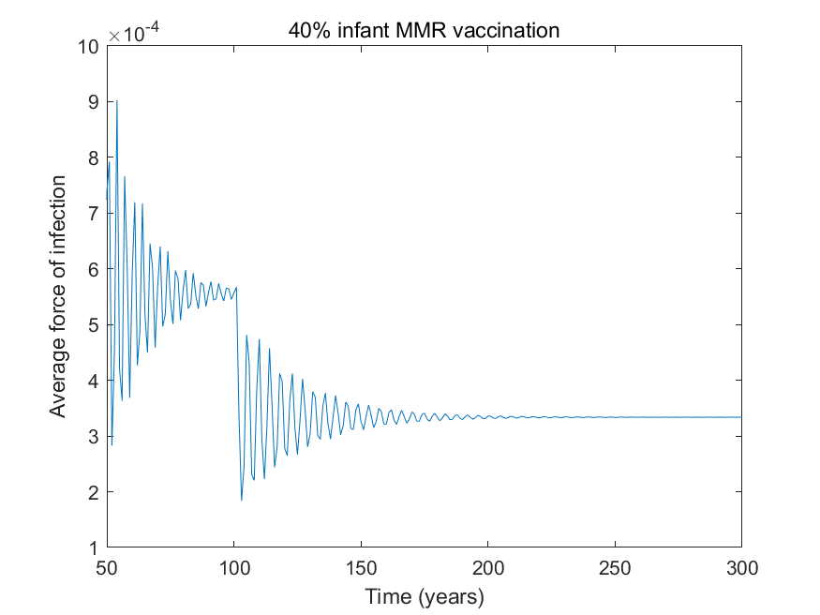

Plot the proportion of 5, 20, 30 and 40 year olds and overall proportion in the population who are susceptible to infection:

1. Why does the average proportion of 5, 20, 30 and 40 year olds who are susceptible to infection increase in the short-term? How soon after the introduction of MMR vaccination does the proportion of 5, 20, 30 and 40 year olds who are susceptible peak and why?

This is because the introduction of vaccination leads to a reduction in the prevalence of infectious individuals and hence in the opportunity for exposure to infection. The proportion of 5, 20, 30, and 40 years olds who are susceptible peaks 5, 20, 30, and 40 years after the introduction of vaccination as the first cohorts of individuals who have been vaccinated reach these ages.

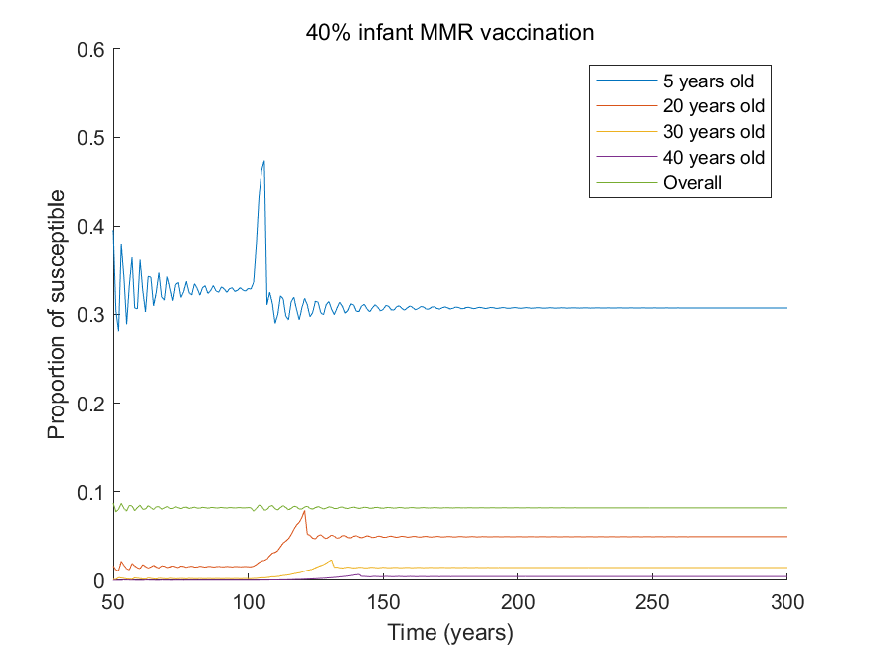

1. How does infant MMR vaccination affect the long-term average proportion of 5, 20, 30 and 40 year olds who are susceptible to infection? Why does this occur?

In the long-term, the proportion of 5 years old who are susceptible is lower than that seen without vaccination because of the direct effect of vaccination. On the other hand, the proportion of adults who are susceptible is greater than that seen without vaccination. This is due to the indirect effect of the vaccination, which leads to a reduction in the force of infection and hence to an increase in the proportion of susceptible.

1. How does the introduction of infant MMR vaccination affect the overall average proportion of individuals who are susceptible to infection and why?

The overall average proportion of susceptible remains unchanged. Since the level of coverage is below the herd immunity (92%), the infection is still endemic and the overall average proportion of susceptible is 8.2%, which is consistent with $1/R_{0}$.

Plot the daily number of new infections per 100,000 among 5, 20, 30 and 40 year olds:

1. How does the introduction of infant MMR vaccination affect the daily number of new infections per 100,000 among 5 year olds? How does it affect the daily number of new infections per 100,000 among 20, 30 and 40 year olds? Why might this occur?

The number of infections at age $a$ and time t depends on the force of infection at time $t$ times the number of susceptible individuals at time $t$.

$$λ\left(t\right)S(a,t)$$

The introduction of vaccination results in a decrease of the force of infection and the opposite trends in the long-term average proportion of susceptible among 5 years old and that among adults. These effects are combined and leads to a decrease in the daily number of new infections per 100,000 among 5 years old, and an increase in the daily number of new infections per 100,000 among adults.

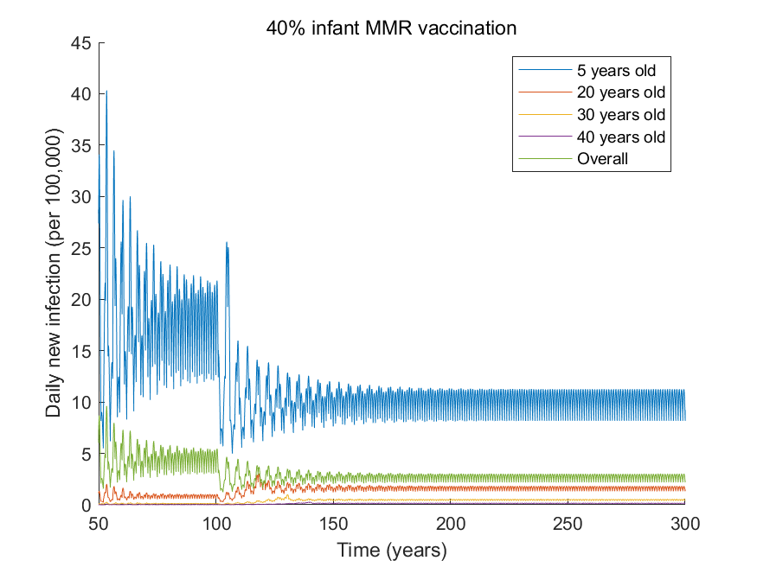

1. How do these age patterns in the daily number of new infections change if you increase the level of vaccination coverage to 50%, 60%, 70%, 80%?

Increasing the vaccination coverage to 50%, 60%, 70%, and 80% leads to similar age patterns in the daily number of new infections per 100,000 to that predicted under 40% vaccination coverage.

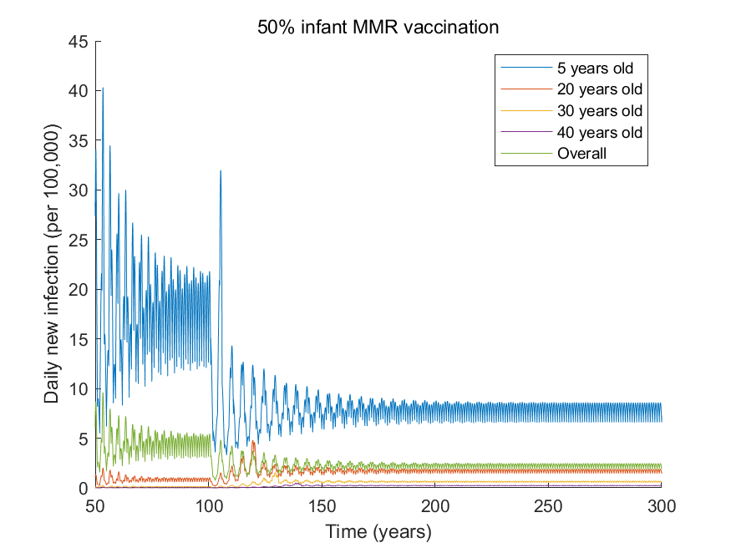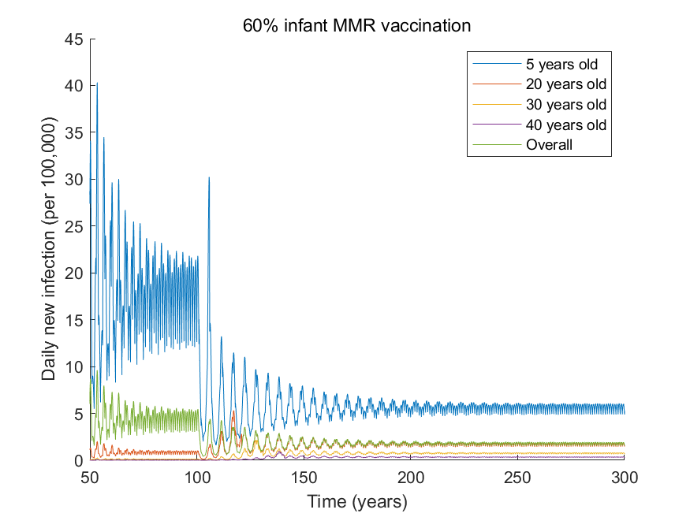

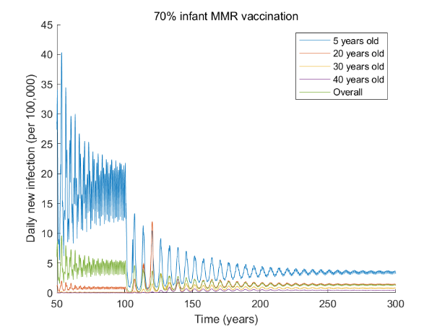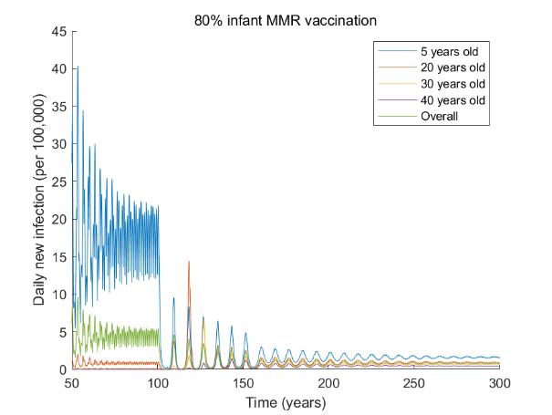

1. What do you conclude about the likely impact of the introduction of infant MMR vaccination on the daily number of new rubella infections/100,000 among adults in China?

The introduction of infant MMR vaccination in China is likely to increase the daily number of new infections per 100,00 among adults when the vaccination coverage is below the herd immunity.

Plot the long-term average age-specific daily number of new infections per 100,000 among 20, 30 and 40 year olds for different levels of vaccination coverage in the range of 0 to 1 among newborns in China and the UK:

1. Should you be most cautious about introducing infant MMR vaccination in China or in the UK and why? How might you amend your vaccination strategy to limit the number of adverse effects?

The incidence of Rubella among adults is higher in the UK than in China, but the introduction of infant vaccination leads to a great relative increase in the daily number of new infections per 100,000 in China than in the UK. Therefore, we might be more cautious about introducing infant vaccination in China than in the UK. To reduce the incidence in the adults we could increase the vaccination coverage over the herd immunity or include adults to the vaccination.

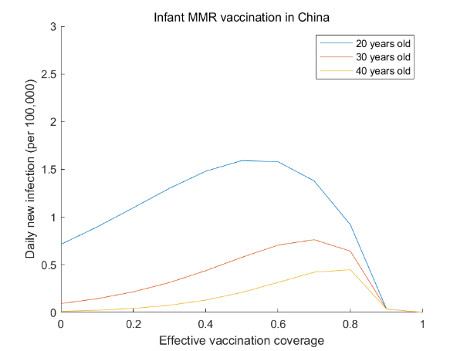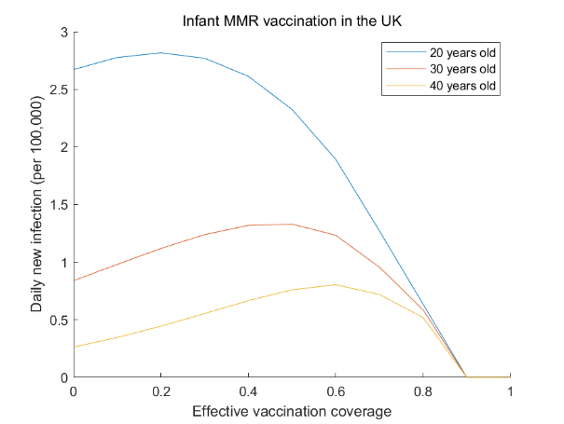

Run the model for China, with a vaccination coverage of 91% (i.e. very close to the herd immunity threshold) and plot the age-specific (5, 20, 30 and 40 year olds) daily number of new infections per 100,000 or of the force of infection:

1. What do you notice about the time interval between the third and fourth epidemics after the introduction of infant MMR vaccination, as compared with that between the first and second and second and third epidemics? Why might this occur?

The time interval between the third and fourth epidemics after the introduction of vaccination is longer than that between the first and second or the second and third epidemics. The introduction of vaccination at a level of effective coverage over the herd immunity leads to a substantial reduction in the force of infection, which means that a large proportion of individuals born before the introduction of vaccination are susceptible. As the proportion of susceptible among these groups reaches the critical threshold the first epidemic occurs. The pool of susceptible individuals is substantially reduced after the first epidemic, so it takes a longer time to build up susceptible individuals to the critical threshold for the next epidemic to occur.

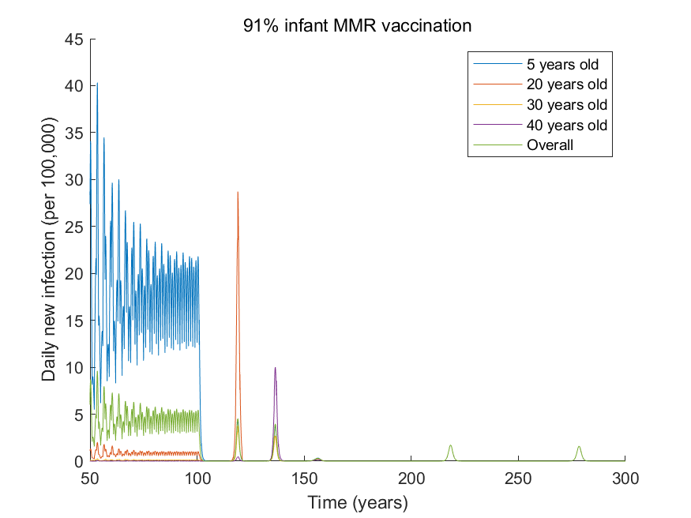

To identify the impact of infant MMR vaccination on rubella infection trends in specific age groups, plot the daily number of new infections per 100,000 among 5, 20, 30 and 40 year olds with the basic reproduction number for rubella in this population is taken to be that for the UK. Vaccination is introduced 150 years after the start of the simulation only for 13 year olds with a coverage of 50%.

1. A How does vaccination among 13 year olds affect
2. the force of infection in the population?

The force of infection goes down only slightly from 0.000317/day to 0.000274/day.

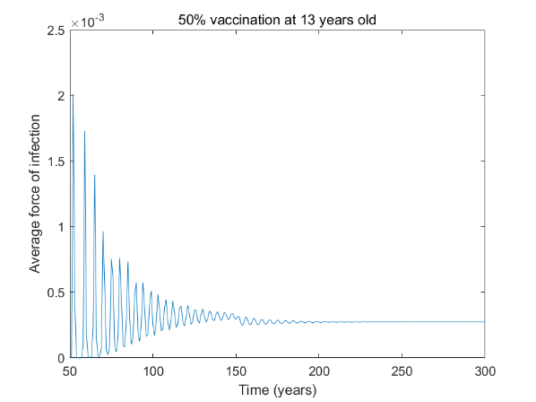

1. the age-specific proportion of individuals who are susceptible?

The proportion of 5 years old who are susceptible increases as the force of infection decreases slightly after the introduction of vaccination. The proportions of susceptible individuals among adults increase in the short term due to the reduced force of infection but decrease in the long term as the vaccinated individuals enter 20, 30, and 40 years of age.

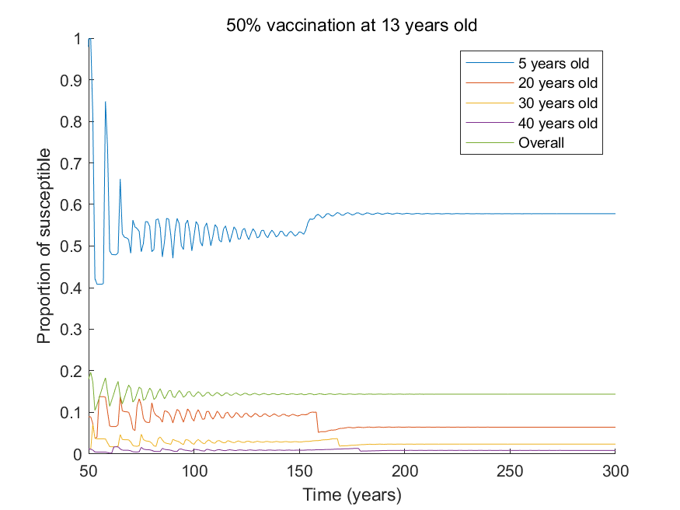

1. the daily number of new infections per 100,000 in different age groups? Why does this occur?

The daily number of new infections per 100,000 remains almost unchanged for 5 years old and decreases slightly for individuals aged over 15 years. Before the introduction of vaccination, most adults are already immune. Therefore, they are rarely affected by the introduction of vaccination among 13 years old and it has a small effect on the overall force of infection. This leads to almost no changes in the new infections among 5 years old.

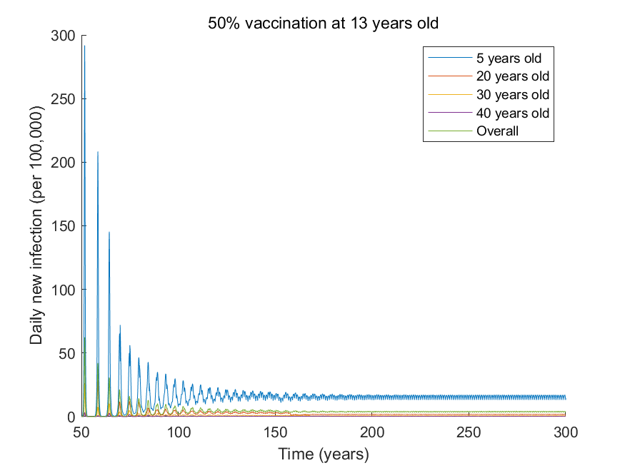

1. How does your answer to the last question change if the level of coverage is 75%? 100%?

Even if we increase the level of coverage, the introduction of vaccination still has small effects on the daily number of new infections per 100,000 among children and adults.

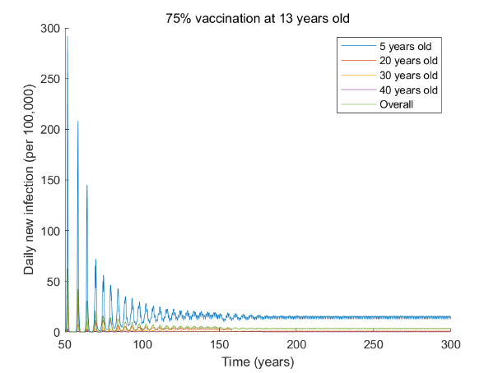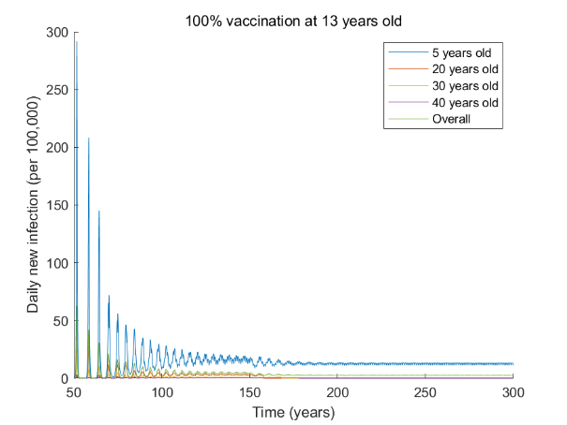

1. What are the relative benefits of a partial vaccination strategy as compared with the strategy of vaccinating all individuals in their first year of life?

The strategy of vaccinating at birth aims to interrupt transmission for all individuals in the long term, while the strategy of vaccinating 13 years old aims to protect individuals who are vulnerable rather than the entire population and has no significant impact on transmission in the young age groups.